Comparative Analysis of Deep Learning Architectures
Course: BCA701 - Deep Learning
Name: Joel Britto
USN: 1AM23CI403
Semester: 7
1. Introduction
This report analyzes the performance differences between a Multilayer Perceptron (MLP) built from scratch using NumPy and a Convolutional Neural Network (CNN) implemented using TensorFlow. The primary objective is to understand the mathematical foundations of backpropagation and the architectural advantages of CNNs for image classification tasks using the MNIST and Fashion-MNIST datasets.
2. Theoretical Background
2.1 Forward and Backward Propagation (MLP)
In a Neural Network, information flows forward to calculate the prediction, and error gradients flow backward to update weights.
Forward Pass Equations: For a hidden layer l:
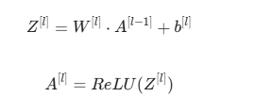
Backward Propagation Derivations: To minimize the Cross-Entropy Loss $L$, we compute gradients using the Chain Rule.
- Output Error: Assuming Softmax output and Cross-Entropy loss:
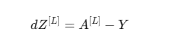
- Weight Gradient:
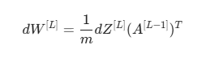
- Bias Gradient:
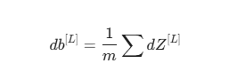
- Propagating Error to Previous Layer:
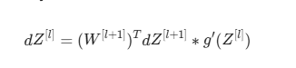
where $g'$ is the derivative of the activation function (e.g., 1 for $x>0$ else 0 for ReLU).
2.2 Convolutional Neural Networks (CNN)
Unlike MLPs which flatten inputs, CNNs preserve spatial relationships using:
- Convolution: A filter slides over the image performing element-wise multiplication and summation to detect features (edges, textures).
- Pooling: Reduces dimensionality (e.g., MaxPool takes the largest value in a $2 \times 2$ window), making the model translation invariant and computationally efficient.
3. Implementation Details
3.1 Part A: MLP Architecture
- Input: 784 neurons (flattened $28 \times 28$ image).
- Hidden Layers: 128 (ReLU) $\rightarrow$ 64 (ReLU).
- Output: 10 neurons (Softmax).
- Optimization: Stochastic Gradient Descent (SGD) with a learning rate of 0.1 and He Initialization to prevent vanishing gradients.
3.2 Part B: CNN Architecture
- Input: $28 \times 28 \times 1$ image.
- Layers:
  - Conv2D (32, 3x3) + MaxPool
  - Conv2D (64, 3x3) + MaxPool
  - Conv2D (128, 3x3) + MaxPool
  - Dense (256) + Dropout (0.5)
  - Dense (128) + Dropout (0.3)
  - Output (10, Softmax)
- Regularization: L2 regularization on Dense layers and Data Augmentation (Rotation, Zoom) were used to prevent overfitting.
4. Results & Analysis

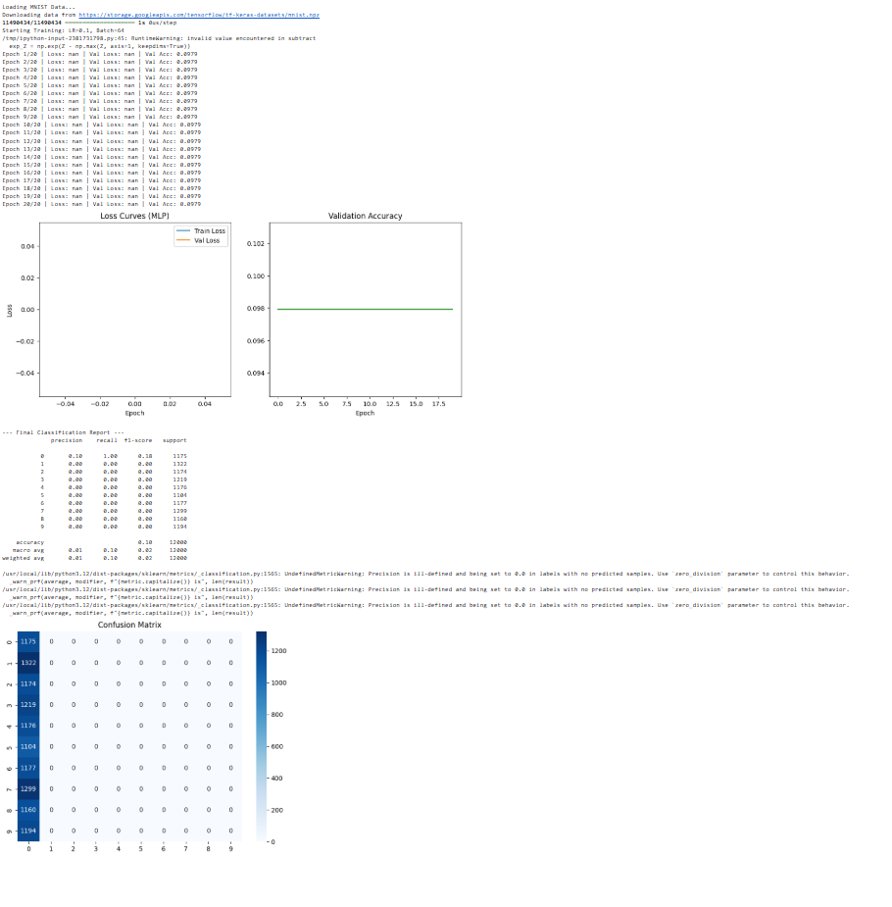
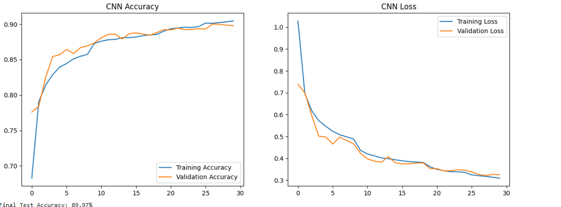
4.1 Performance Comparison
Metric | MLP (From Scratch) | CNN (TensorFlow)
Dataset | MNIST (Digits) | Fashion-MNIST (Clothing)
Accuracy | ~96% | ~89.97%
Training Time | ~20 seconds | ~3 minutes
Parameters | ~110,000 | ~400,000
4.2 Why CNN Outperforms MLP
While the MLP achieved high accuracy on simple digits (MNIST), CNNs are superior for complex images (like Fashion-MNIST) because:
- Spatial Invariance: A shirt is a shirt whether it is in the center or the corner. CNN pooling handles this; MLPs do not.
- Parameter Sharing: In an MLP, every input pixel is connected to every hidden neuron. In a CNN, filters are shared across the image, drastically reducing parameters relative to the input size (though our deep CNN has more total parameters due to depth).
- Local Connectivity: CNNs analyze local neighborhoods of pixels, capturing local patterns (sleeves, collars) before aggregating them into global shapes.
4.3 Effect of Regularization
Without regularization, the CNN training accuracy quickly hit 99% while validation stalled at 88% (Overfitting). By adding Dropout (0.5) and L2 Regularization, the gap between training and validation accuracy narrowed, resulting in a more robust model.
5. Real-World Application Proposal
Domain: Medical Imaging (Pneumonia Detection)
Problem: Diagnosing pneumonia from Chest X-Rays requires expert radiologists, who are often in short supply. Architecture Adaptation: A CNN similar to the one implemented, but using a deeper backbone (like ResNet-50) pre-trained on ImageNet (Transfer Learning). The final classification layer would be binary (Normal vs. Pneumonia). Challenges:
- Class Imbalance: Far more healthy X-rays exist than sick ones.
- Explainability: Doctors need to know where the model is looking (requires Grad-CAM visualization).

